

DEPARTMENT of COMPUTER SCIENCE & ENGINEERING

SOUTHEAST UNIVERSITY



**Internship Report on**



**Web Design & Development**

*A dissertation submitted to the Southeast University in partial fulfillment of the requirements for the degree of B. Sc. in Computer Science & Engineering*

|  |  |
| --- | --- |
| Submitted by  **Atiq Israk Niloy**  2016100000039  Batch 43  Department of Computer Science and Engineering  Southeast University | Supervised by  **Shifat Ahmed**  Lecturer and Coordinator  Department of Computer Science and Engineering  Southeast University |

**Copyright © Atiq Israk 2020**

**Letter of transmittal**

October 22, 2020

The Chairman

Department of Computer Science & Engineering

Southeast University

Banani, Dhaka 1212

Through: Supervisor, Shifat Ahmed

**Subject: Submission of Internship Report.**

Dear Sir,

With due respect, it is a great pleasure and privilege to present the internship report titled “Web Design and Development” as partial fulfillment of my CSE Program.

Throughout the study, I tried with the best of my capacity to accommodate as much information and relevant issues as possible and tried to follow the instructions as you have suggested. I tried my best to make this report as informative as possible. This report explores the “Web Design and Development of REM Eco Savers Ltd..” I sincerely believe that it will satisfy your requirements.

Therefore, I sincerely hope that you will appreciate my effort and I will be grateful if my report is accepted for the appropriate purpose.

With Appreciation,

Sincerely yours,

|  |  |
| --- | --- |
| **Atiq Israk Niloy**  2016100000039  Batch 43  Department of Computer Science and Engineering  Southeast University  Cell: +8801701893882  E-mail: atiqisrak@gmail.com | Supervised by  **Shifat Ahmed**  Lecturer and Coordinator  Department of Computer Science and Engineering  Southeast University |

**Letter of Endorsement**

This is to certify that the internship report titled “Web Design and Development” has been submitted by Atiq Israk Niloy in the partial fulfillment of the requirements for awarding the degree (B.Sc. in CSE) in the department of Computer of Science & Engineering of Southeast University. This is a record analysis carried out by Atiq Israk Niloy, ID: 2016100000039, under my supervision. No part of the internship report has been submitted for any other degree and the performance of the student has been accepted as satisfactory.

|  |  |
| --- | --- |
| **Approved by the Co-Supervisor**  **Nur-E-Elias**  Managing Director  REM Eco Savers Limited | **Approved by the Supervisor**  **Shifat Ahmed**  Lecturer and Coordinator  Department of Computer Science and Engineering  Southeast University |

**ACKNOWLEDGMENT**

I wish to express my most significant thankfulness to every last one of the people who helped me, some way or another, to complete this project. From the outset, I offer thanks to Almighty Allah who gave me the strength, direction, purpose, and patience all through the project.

I would like to thank our department head, Shahriar Manzoor and my supervisor Shifat Ahmed for approving my report. And I am thankful to my project co-supervisor Nur E Elias sir for all his patience, guidance, direction, and support during the execution of this project. Through his expert guidance, I was able to overcome all the obstacles that I encountered in these enduring four months of my project. He always gave me immense hope and direction every time I consulted with him over problems relating to my project.

Finally, I am thankful to my friends and family for their unconditional love and support.

**ABSTRACT**

This report is the reflection and also the journey of my four months internship period along with the highlights of what I learned through errors, work responsibilities, and the importance of the internship program at REM Eco Savers Ltd. The knowledge I have gained as a new developer on web application development, new frameworks, and also how to work in an office environment is splendid. As an intern, my work was to learn and focus on web application projects. In this report, I have focused on my work territory and explained my achievements, which I have got through my internship at REM Eco Savers Ltd.

**TABLE OF CONTENTS**

**CHAPTER TITLE PAGE**

**INTRODUCTION** **1**

**Objectives** **2**

**Scope of the report** **2**

**Methodology** **3**

**Limitation** **4**

**Arrangement of the report** **4**

**Services** **7**

**Departments** **8**

Development Tools and Languages of REM Eco Savers Ltd. 8

**Roles and Responsibilities** **9**

**Working Environment** **9**

TOOLS & TECHNOLOGIES 11

**Overview** **11**

**Comparison** **12**

1. The most popular CMS in the world 13

2. Open Source with room for expansion 13

3. Highly customizable for great flexibility 13

4. Designed for anyone, not just developers 14

5. Lower setup and maintenance costs 14

**Setup Guideline** **15**

1. Load wp-config.php File 15

2. Setup Default Constants 15

3. Load advanced-cache.php File 15

4. Load wp-content/db.php File 16

5. Connect MySQL and Select Database 16

6. Load object-cache.php or wp-includes/cache.php File 17

7. Load wp-content/sunrise.php File 17

8. Load Localization Library 17

9. Load Multisite Plugins 17

10. Do Action ‘muplugins_loaded’ 18

11. Load Active Plugins 18

12. Load pluggable.php File 19

13. Do Action ‘plugins_loaded’ 19

14. Load Rewrite Rules 19

15. Instantiate $wp_query, $wp_rewrite, $wp 19

16. Do Action ‘setup_theme’ 20

17. Load Child Theme’s functions.php File 20

18. Load Parent Theme’s functions.php File 20

19. Do Action ‘after_setup_theme’ 21

21. Do Action ‘init’ 21

22. Do Action ‘widget_init’ 21

23. Run wp() 22

24. Parse Request 22

25. Run Query 22

26. Do Action ‘template_redirect’ 23

27. Load Feed Template 23

28. Load Template 23

29. Do Action ‘shutdown’ 23

**The language used for Web Development** **24**

**Editor: Visual Studio Code and CMS** **24**

**Project Design** **25**

**4.1.1 USE-CASE Diagram** **26**

Class diagram 27

**Project functionalities** **27**

**Implementation** **28**

**Database Structure** **39**

**Project Analysis** **41**

CONCLUSION 43

**Conclusion** **43**

**Scope of Further Development** **44**

Reference 45

|  |  |  |
| --- | --- | --- |
| **1** | **INTRODUCTION 1** | |
|  | 1.1 Objectives | 2 |
|  | 1.2 Scope of the Report | 2 |
|  | 1.3 Methodology | 3 |
|  | 1.4 Limitation | 4 |
|  | 1.5 Arrangement of The Report | 4 |
|  |  |  |
| **2** | **COMPANY PROFILE** | **5** |
|  | 2.1 Services | 6 |
|  | 2.2 Departments | 7 |
|  | 2.3 Roles and Responsibilities | 7 |
|  | 2.4 Working Environment | 8 |
|  |  |  |
| **3** | **TOOLS AND TECHNOLOGIES** | **9** |
|  | 3.1 Overview | 9 |
|  | 3.2 Why WordPress | 9 |
|  | 3.3 Comparison | 1 |
|  | 3.4 Node Modules | 11 |
|  | 3.5 The Language used for Web Development | 12 |
|  | 3.6 Editor: Visual Studio Code | 12 |
|  |  |  |
| **4** | **DEVELOPMENT PROCESS** | **13** |
|  | 4.1 Project Design | 13 |
|  | 4.1.1 USE-CASE Diagram | 14 |
|  | 4.1.2 CLASS Diagram | 15 |
|  | 4.2 Project Functionalities | 15 |
|  | 4.3 Implementation | 16 |
|  | 4.4 Database Structure | 24 |
|  | 4.5 Project Analysis | 25 |
|  |  |  |
| **5** | **CONCLUSION** | **28** |
|  | 5.1 Conclusion | 28 |
|  | 5.2 Scope of Further Development | 29 |
|  |  |  |
|  | **Reference** | **30** |
|  |  |  |

**LIST OF TABLES**

|  |  |  |
| --- | --- | --- |
| **NO.** | **TITLE** | **PAGE** |
| 2.1 | Overview of company profile | 5 |
| 2.2 | Tools and Languages List used by me for the development of a different type of products at REM Eco Savers Ltd. | 7 |
| 2.3 | List of Database Management System at REM Eco Savers Ltd. I used for the development of my product | 7 |
|  |  |  |
|  |  |  |
|  |  |  |
|  |  |  |

**LIST OF FIGURES**

|  |  |  |
| --- | --- | --- |
| **NO.** | **TITLE** | **PAGE** |
| 3.1 | Google Trends comparison result in the USA | 10 |
| 4.1 | Use Case diagram | 14 |
| 4.2 | Class diagram | 15 |
| 4.3 | Home page | 16 |
| 4.4 | The Header of the Project | 17 |
| 4.5 | Body of the project | 17 |
| 4.6 | JSON data | 18 |
| 4.7 | Code for API get request | 19 |
| 4.8 | Footer part of the project | 19 |
| 4.9 | Footer portion of the project | 20 |
| 4.10 | Product details page | 21 |
| 4.11 | Cart page of the project | 21 |
| 4.12 | Cart page of the project | 22 |
| 4.13 | User registration page of the project | 22 |
| 4.14 | User login page of the project | 23 |
| 4.15 | Database Structure | 24 |
| 4.16 | User Table Database Structure | 24 |
| 4.17 | Cart Table Database Structure | 25 |
| 4.18 | Home page of cabhubbd.com | 26 |
| 4.19 | Service details page of cabhubbd.com | 27 |

**LIST OF ABBREVIATIONS**

CSE Computer Science and Engineering

SEU Southeast University

PHP Personal Home Page

HTML Hypertext Markup Language

CSS Cascading Style Sheets

JS JavaScript

API Application programming interface

# 

INTRODUCTION

An e-commerce internet application is a web portal that want to sell, buy, ANd exchange products and services over the net and is also referred to as an electronic business system. Day by day it's gaining several quality and then that reason I offer concern towards the e-commerce platform and develop a website that may be useful for the users.

I give priority to the main concept of e-commerce platform which is business in a web app and there are four types of e-commerce web platforms e.g. business-to-business (B2B), consumer-to-consumer (C2C), business-to-consumer (B2C), and consumer-to-business (C2B). Our project focuses on the business to consumer (B2C) type and has a remarkable capacity for business and consumers.

I joined REM Eco Savers Ltd. which is a popular private software company in Bangladesh for IT services as an intern web developer. I was suggested to learn their work process and how to maintain their standards so that I can understand how they work together and how they manage the framework to complete their project. After that, I found the opportunity to work with their web application development team. In the time of my internship, I have gained practical knowledge on web development, new frameworks, and also gained how to maintain a web application, different programming languages, learn about security and office etiquette, and mostly how a software firm works for the satisfaction of clients. Also, I have learned the most popular JavaScript library, WordPress JS, and Bootstrap using the coding technique and design skills I have learned in my courses at my university. After that I have successfully finished my task in due time and which gives the previous e-commerce project a more effective look and makes it more user friendly.

In this report, I have described all my working processes and the achievement area which I received from REM Eco Savers Ltd.

* 1. Objectives

Behind the report, there are general objectives and specific objectives to fulfill which are demonstrated below:

## General Objective:

This internship report is created for completing the Bachelor’s degree requirements in the computer science engineering program under the Faculty of Computer Science and Engineering (CSE), Southeast University.

### Specific Objective:

1. To give an outline of REM Eco Savers Ltd., including its products, mission, services, work environment, vision, and facilities.
2. Learn and get knowledge about their working style with the client and proper utilization.
3. The initial target to learn how to manage, coordinate, and communicate teamwork and make a profitable product.
4. Develop my skill, as a developer, implementation and maintenance of web app, and time management as an intern.
   1. Scope of the report

The Department of Computer Science and Engineering (CSE) at the University of Southeast University (SEU) has an internship program to complete their Bachelor of Science program for fulfilling the requirements this report is prepared for. The goal of this internship is to teach a student how the real job market works and acquire practical knowledge of how to handle the office & clients. Moreover, the biggest challenge for an intern is to convert the theoretical knowledge into practical life working experience. Also, this report is concentrated on analytical enhancement and web application development progress.

## Methodology

For completing this report, data has been acquired from both primary and secondary sources.

### Primary Sources:

The important information has been gathered by face to face interviewing authorities and by asking employees by working side by side and deskwork. To extend, acquired data is being used to complete the report.

I communicated with the company experts for information are:

    i.            Nur E Elias, Managing Director, REM Eco Savers Ltd.

    ii.            Nawaz Alam

iii. Masud Pervez, Director

Moreover, a few of the information I have been acquired by commonsense that I have to experience as an internee.

### Secondary Sources:

My office provided me with a few information in the form of files and documents. I also take some significant help from web resources, researches, and articles that motivate me to finish my report and those links have been given in the references.

## Limitation

This report is made with the given information that I have collected from the employees of REM Eco Savers Ltd. I have confronted such a massive number of challenges. Some data that I need from the company has not been given to me for their privacy policy and some of my colleagues think that the data I need from them is confidential and they would prefer not to disclose it in public. I couldn't add some information to my report for the company security reasons. Another issue was as far as possible is the time limit. Since we have just an exceptionally brief timeframe, it is extremely hard for me to investigate and analyze everything and make the report extremely clear, however in this brief timeframe I have attempted my best to finish the report.

## Arrangement of the report

In chapter one, I have described the introduction, main objective, scope of the report, and the methodology. After that, I give concern to chapter two and in this chapter, I mainly describe my company profiles. I give a full description of the service, department, working environment, and responsibilities of the company. Then, I give concern about the tools and technologies part of the project and I represent all technical details in chapter 3. In chapter 4, I give full attention to the project development process and its attributes. Finally, in chapter 5, I explain and conclude part of my internship report.

COMPANY PROFILE

In this section, we mainly focus on the internship company profile and describe briefly about that company. In section 2.1, we will describe the service of REM Eco Savers Ltd. After that, we will give short notes about the departments and roles and responsibilities of that company in section 2.2 and section 2.3 respectively.

REM Eco Savers Ltd. is one of the growing alternate plastic companies in Bangladesh with a team of more than 100 people. We are celebrated for our unpredictable organization culture. Our experience and huge arrangement permit us to convey services on an unmatched scale. We have built leading brands within the digital space and are one of the best alternate plastic production companies. REM Eco Savers Ltd. believes in customer satisfaction and its mission to build up a strong relationship with customers & partners. Information on Company given in below.

**Table 2.1:** Overview of company profile.

|  |  |
| --- | --- |
| **Company Name** | **REM Eco Savers Ltd.** |
| **Address** | Shah Ali Plaza, Mirpur 10 Roundabout, 7 Floor, Space no # 804, 1/A Senpara Parbata 1216 Mirpur, Dhaka Division, Bangladesh |
| **Contact Number** | +8801727863088 |
| **Year of Establishment** | 2019 |
| **Email** | remecosavers@gmail.com |
| **Company Website** | http://www.rem-bd.com |

## Services

Our mission is to understand the customer’s requirements & produce and supply the products in due time. We provide devoted flexibility to custom-built solutions & dedicated to staying vanguard with reliable & proven technology to:

1. Client satisfaction and giving them the most pioneering services.
2. Thrive as a creative and inspire the workforce.
3. Building up a strong, friendly, and compassionate relationship with clients and business partners.

## The Vision of REM Eco Savers Ltd.

To understand the vision of REM Eco Savers Ltd. will:

1. Fulfill the demands of society and works positively towards the interests of humanity
2. Attain a state of profitability in the entirety of its tasks through the rugged and proficient utilization of assets, selection of suitable innovation, and arrangement with the center skills.
3. Develop its workers by enabling fortifying and compensating headway.
4. Encourage and aid the personal enhancement of the administrations of its providers and merchants.
5. Providing the best and administrations of high and reliable quality, guaranteeing an incentive to its customers. [1], [2].

## Departments

## Development Tools and Languages of REM Eco Savers Ltd.

**Table 2.2:** Tools and Languages List used by me for the development of the different types of products at REM Eco Savers Ltd.

|  |  |
| --- | --- |
| **No.** | **Web Technologies** |
| **01** | PHP, Bootstrap, SCSS (Web and App Development) |
| **02** | JavaScript (Programming Language for the Web) |
| **03** | HTML5 (Programming Language for the Web) |
| **04** | Apache (Runtime or server environment) |
| **05** | Adobe Illustrator (Illustration) |

### Database Management Systems

**Table 2.3:** List of Database Management System at REM Eco Savers Ltd. I used in the development of my product.

|  |  |
| --- | --- |
| **No.** | **Database Systems** |
| **01** | MySQL |
| **02** | API URL call for JSON data |

## Roles and Responsibilities

We comprehend that each business is unique and their product needs are distinctive as well. Remembering that, we have manufactured administrations that can be custom fitted to meet every one of your necessities.

### Web Development

REM Eco Savers Ltd. provides all facets of web application development, including graphic design, custom websites, portals, intranets, and extranets.

### Website Maintenance

REM Eco Savers Ltd. provides Website maintenance and support services.

### Web Hosting & Domain name

REM Eco Savers Ltd. provides all kinds of Domain name services and web hosting.

1. **Software Development**

REM Eco Savers Ltd. software teams help our customers build customized software and the development of services for a wide variety of verticals and business domains.

## Working Environment

As an intern, I am blessed that I get the opportunity to explore an amazing work environment at REM Eco Savers Ltd. All of my colleagues are cooperative, friendly, and understanding. I never felt left out because everyone is so inspiring and optimistic. My office has a place called the lobby. We used to seat and talk about our ideas, vision, and our future goal.

TOOLS & TECHNOLOGIES

## Overview

Nowadays developers are comfortable with the framework for developing web applications, that is why Laravel, Angular, Express, WordPress, Django, WordPress, and other MVC-based frameworks are mostly used by web application developers around the world.

## **1.1**    **Why WordPress**

While researching with various web development technologies for developing my project I found that WordPress is the most popular development platform that is used for building the reusable user interface (UI) component. With WordPress, a web application can be built that doesn't need any reload for changing the page’s data, which makes the application become faster & more scalable & it also makes the application user friendly.

Why I have selected WordPress for my project there are some points are given below:

1. **Simplicity & fast learning curve:** WordPress has a very simple & lightweight PHP library so any developer who is familiar with PHP can easily start with WordPress. The learning materials are easily understandable and approachable.
2. **Reusable Components:** WordPress has a component-based structure so we don’t need to write the same code for the smaller element into different web pages which is more efficient and time-consuming for drag and drop.
3. **Fast Rendering:** WordPress loads very quickly because WordPress uses Virtual DOM to render the website. WordPress with components to develop a website, and Virtual DOM simply replaces components instead of replacing all of the code for a website.
4. **Clean Abstraction:** WordPress does not architectures like MVC, after all, it is only about the view level and you can design the architecture of your app according to your wishes [4], [5], [6].

## Comparison

WordPress is an open-source website creation platform that is written in PHP and uses a MySQL database. In non-geek speak, it’s probably the easiest and most powerful blogging and website content management system (or CMS) in existence today. Every developer who is working with web & mobile application development is very familiar with WordPress so WordPress becomes the most popular & powerful application development platform. WordPress is an excellent website platform for a variety of websites. From blogging to e-commerce to business and portfolio websites, WordPress is a versatile CMS. Designed with usability and flexibility in mind, WordPress is an excellent solution for both large and small websites.

While I am researching on the internet, I found that 59% of developers use WordPress compared with other technologies which shows the large popularity of WordPress around the world.

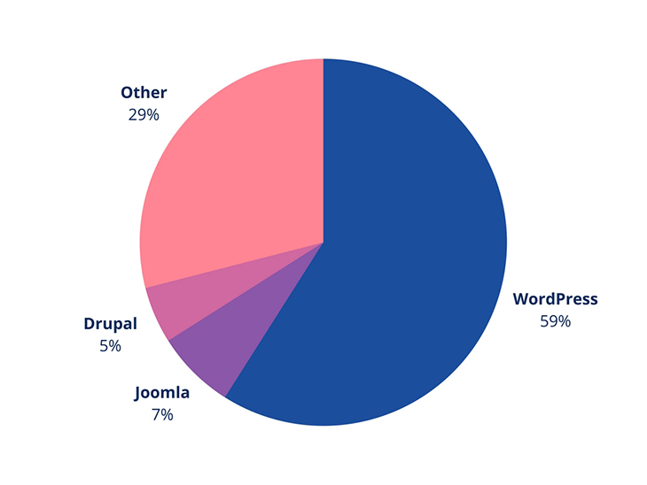

**Figure 3.1:** Google Trends comparison result in the USA

In WordPress, many advantages stay along with their limitations.

## Interesting facts about WordPress:

### 1. The most popular CMS in the world

WordPress holds the largest CMS market share by far and currently accounts for over a quarter of all websites. As a result, many users are already familiar with the WordPress CMS, requiring less staff training when building a new site.

### 2. Open Source with room for expansion

WordPress can be self-hosted, so there are no costs associated with downloading, installing, and upgrading. There are more than 50,000 WordPress plugins (often free), such as slideshows, contact forms, SEO optimization, etc.

### 3. Highly customizable for great flexibility

WordPress is popular because it meets the demands of many users with its flexible framework, which allows designers and developers to create and modify layouts and applications. Coupled with user-generated extensions, websites are no longer limited by enterprise extensions.

Our team has experience extending WordPress functionality, as well as incorporating a wide range of plugins, to meet our clients’ unique demands.

### 4. Designed for anyone, not just developers

Before WordPress became a popular CMS for website development, it was developed for non-tech savvy bloggers. So, most of the user-interface components are easy to use, and there are written and recorded manuals available for easily learning how to use WordPress functions. Our team handles all the complexities of setting up and customizing your website; all you have to do is to update the content on pages, posts, widgets, etc.

One of the premium plugins we provide to our clients offers both written and video user manuals for WordPress to facilitate onboarding with the CMS.

### 5. Lower setup and maintenance costs

According to DeviousMedia, WordPress incurs fewer setup, customization, and maintenance costs in comparison to other Open Source CMS like Drupal and Joomla. Additionally, it is relatively easier to find WordPress designers and developers if more customization or development is necessary in the future. You don’t get locked down by a static website or proprietary CMS that is costly to tweak after initial development.

WordPress can be a quick win for improving your customer experience. Contact us today to learn more.

## Setup Guideline

### 1. Load wp-config.php File

The wp-config.php is the WordPress configuration file. It sets global variables for a WordPress site and contains your WordPress database information. This is the first file WordPress loads for apparent reasons. Learn more [about the wp-config.php file and how to edit it](https://www.wpbeginner.com/beginners-guide/how-to-edit-wp-config-php-file-in-wordpress/).

### 2. Setup Default Constants

After loading the wp-config.php file, WordPress will move on to set default constants. This includes information like default [WordPress upload location](https://www.wpbeginner.com/wp-tutorials/how-to-change-the-default-media-upload-location-in-wordpress-3-5/), [maximum file sizes](https://www.wpbeginner.com/wp-tutorials/how-to-increase-the-maximum-file-upload-size-in-wordpress/), and other default constants set in wp-config.php file.

### 3. Load advanced-cache.php File

If an advanced-cache.php file exists on your site, then WordPress will load it next. This file acts as a drop-in file and is used by several [popular plugins](https://www.wpbeginner.com/showcase/24-must-have-wordpress-plugins-for-business-websites/), particularly WordPress caching plugins. If your site is using this file, then you will see a new item on the plugins screen called Drop-ins.

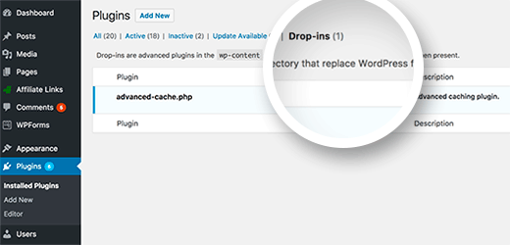

### 4. Load wp-content/db.php File

WordPress allows developers to create their own database abstraction layers and load them in a db.php file placed inside the wp-content folder. It is commonly used by WordPress caching plugins to improve database performance. If your website has this file present, then WordPress will load it.

### 5. Connect MySQL and Select Database

WordPress now has enough information to proceed further. It will move on to connect to the MySQL server and select the database.

If WordPress is unable to connect to the database, then you will see the “[Error establishing database connection](https://www.wpbeginner.com/wp-tutorials/how-to-fix-the-error-establishing-a-database-connection-in-wordpress/)” error and WordPress will quit right here.

If everything works fine, then it will move on to the next steps.

### 6. Load object-cache.php or wp-includes/cache.php File

WordPress will now look for an object-cache.php file. If it doesn’t exist, then WordPress will move on to load the wp-includes/cache.php file.

### 7. Load wp-content/sunrise.php File

If it is a [multisite network](https://www.wpbeginner.com/wp-tutorials/how-to-install-and-setup-wordpress-multisite-network/), then WordPress will now look for a sunrise.php file if it exists in the wp-content folder.

### 8. Load Localization Library

WordPress will now load the 10n.php library in the wp-includes folder. This file loads the WordPress localization system, loads translations, sets locales, etc. See our guide on [how to use WordPress in other languages](https://www.wpbeginner.com/wp-tutorials/how-to-install-wordpress-in-other-languages/).

### 9. Load Multisite Plugins

If it is a multisite network, then WordPress will now load the multisite plugins. Learn more about [how plugins work on WordPress multisite network](https://www.wpbeginner.com/beginners-guide/why-do-you-not-see-all-plugins-on-wordpress-multisite-installs/).

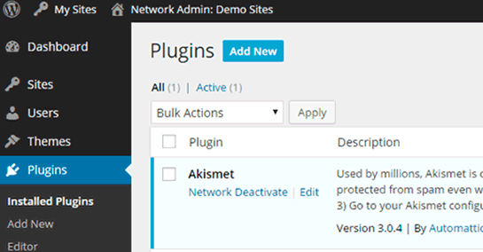

### 10. Do Action ‘muplugins_loaded’

The [action](https://www.wpbeginner.com/glossary/action/) muplugins_loaded is now run by WordPress. This action is available only to network activated plugins on a WordPress multisite.

### 11. Load Active Plugins

WordPress will now load all active plugins on the site. It does that by looking in the active_plugins entry in the options table of your WordPress database. This allows WordPress to ignore plugins that are installed on your site but not activated.

### 12. Load pluggable.php File

The pluggable.php file contains functions that can be redefined by WordPress plugins. WordPress will now see if the functions inside this file are already defined by another plugin. Otherwise, it will define those functions itself.

### 13. Do Action ‘plugins_loaded’

WordPress will now run the action ‘plugins_loaded’. It allows developers to hook their functions to run after all active plugins have been loaded.

### 14. Load Rewrite Rules

WordPress will now load the rewrite rules. These rewrite rules help WordPress use [SEO friendly URLs](https://www.wpbeginner.com/wp-tutorials/seo-friendly-url-structure-for-wordpress/).

### 15. Instantiate $wp_query, $wp_rewrite, $wp

At this point WordPress loads the following objects:

$wp_query: The global instance that holds WP_Query class. It tells WordPress what content is requested in a typical WordPress query format.

$wp_rewrite: The global instance that holds your WP_Rewrite class. It contains your rewrite rules and functions which tell WordPress which URL to use to display the requested content.

$wp: The global instance of the WP class which contains functions that will parse your request and perform the main query.

### 16. Do Action ‘setup_theme’

WordPress will now move on to run ‘setup_theme’ action. This action runs before your WordPress theme is loaded.

### 17. Load Child Theme’s functions.php File

The functions.php file acts as plugin and is used in WordPress themes to add theme specific features to your website. If you are using a [child theme](https://www.wpbeginner.com/beginners-guide/wordpress-child-theme-pros-cons/), then WordPress will now load your child theme’s [functions.php](https://www.wpbeginner.com/glossary/functions-php/) file.

Otherwise, it will go on and load your current active theme’s functions.php file.

### 18. Load Parent Theme’s functions.php File

If you are using a child theme, then WordPress will now load your parent theme’s functions.php file.

### 19. Do Action ‘after_setup_theme’

This action runs after WordPress has set up the theme and loaded theme functions. It is the first action available to themes.

20. Setup Current User Object

At this point, WordPress loads the current user object. It allows WordPress to manage the request in accordance with the [user’s role and capabilities](https://www.wpbeginner.com/beginners-guide/wordpress-user-roles-and-permissions/).

### 21. Do Action ‘init’

WordPress has so far loaded all the crucial information it needs. Now it fires the ‘init’ action.

This action allows developers to add code that needs to be executed after WordPress has loaded all previously mentioned information.

### 22. Do Action ‘widget_init’

The widget_init action allows developers to [register widgets](https://www.wpbeginner.com/wp-tutorials/how-to-create-a-custom-wordpress-widget/) and run code they needed to run at this time.

### 23. Run wp()

WordPress now calls wp() function which is located in wp-includes/functions.php file. It sets up the WordPress query globals $wp, $wp_query, $wp_the_query and then calls $wp->main.

### 24. Parse Request

Now WordPress has all the information it needs to parse the user request. It starts by checking the rewrite rules to match the user’s request.

And then runs query variable filters, request action hook, and sends header request.

### 25. Run Query

If no content matches the query, then WordPress will set the is_404 variable.

Otherwise, WordPress will go on to load query variables.

It will then run WP_Query->get_posts().

Next, it fires DO_ACTION_REF_ARRAY ‘pre_get_posts’ action with WP_Query object.

WordPress will now run apply_filters to clean up queries and run some final checks.

Now it fetches posts from the database and applies posts_results and the_posts filters.

The query part ends with WordPress returning the posts.

### 26. Do Action ‘template_redirect’

WordPress will now run the template_redirect action. This hook runs just before WordPress determines which template page to load.

### 27. Load Feed Template

If the requested content is an [RSS feed](https://www.wpbeginner.com/beginners-guide/what-is-rss-how-to-use-rss-in-wordpress/), then WordPress loads the feed template.

### 28. Load Template

WordPress will now look for the template file based on the WordPress template hierarchy. It then loads the template which usually contains a [WordPress loop](https://www.wpbeginner.com/glossary/loop/).

### 29. Do Action ‘shutdown’

Just before ending all PHP execution, WordPress fires the last action called shutdown.

WordPress stops working here. It has run the code and generated the user’s requested web page.

Now, your web hosting server replies to the user’s request by sending them the web page generated by WordPress. This page contains HTML, CSS, and Javascript code, which tells the user’s browser how to display it on screen.

## The language used for Web Development

I have used HTML5, CSS3, and JavaScript for the development of web applications.

## Editor: Visual Studio Code and CMS

Visual Studio Code (VS Code) is a source code editorial manager created by Microsoft that can be run on Windows, macOS, and Linux. It is free, open-source, and offers help for investigating just as implicit Git variant control, linguistic structure features, scraps, etc. The UI of the VS Code is exceptionally adjustable, as clients can change to various subjects, console alternate ways, and inclinations [3], [7], [8].

WordPress is a website builder and content management system. It is an open-source software that anyone can use to make any kind of website imaginable.

It started out as a blogging platform in 2003 but soon transformed into a CMS and later a full-fledged website building platform. Today it powers more than 38% of all websites on the internet.

**DEVELOPMENT PROCESS**

## Project Design

A good project plan and design makes any project a lot easier. Project design is an initial stage of the project. When I joined REM Eco Savers Ltd. as an intern, my initial work was to rebuild an existing website by making it fast, dynamic, and responsive and it is challenging. I worked day and night to accomplish this task by using HTML, CSS, Bootstrap, and JS, a cutting-edge technology. In this section, we give full concern towards the use-case diagram of my internship project and that will be described in the portion of 4.1.1. After completing that, we will give focus on the class diagram and represent it in section 4.1.2. and Project functionalities in section 4.2, implementation in section 4.3. Database structure and Project Analysis in section 4.4 and 4.5.

## 4.1.1 USE-CASE Diagram

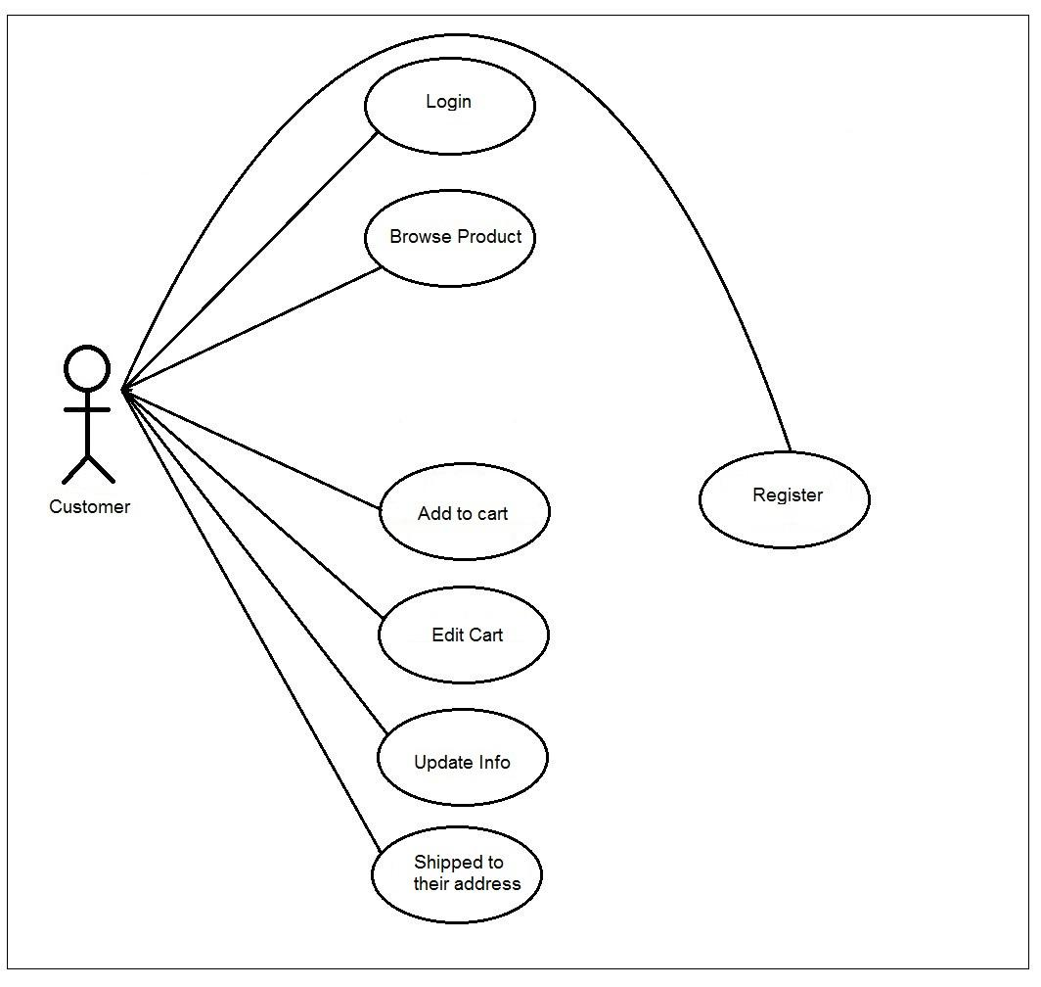

**Figure 4.1:** Use Case diagram

The Use Case Diagram given above shows a use case diagram is a graphic depiction of the interactions among the elements of a system. Use Case Diagram portrayed the system's functionality and necessity by using actors and use cases. It is represented by either circles or ellipses.

### Class diagram

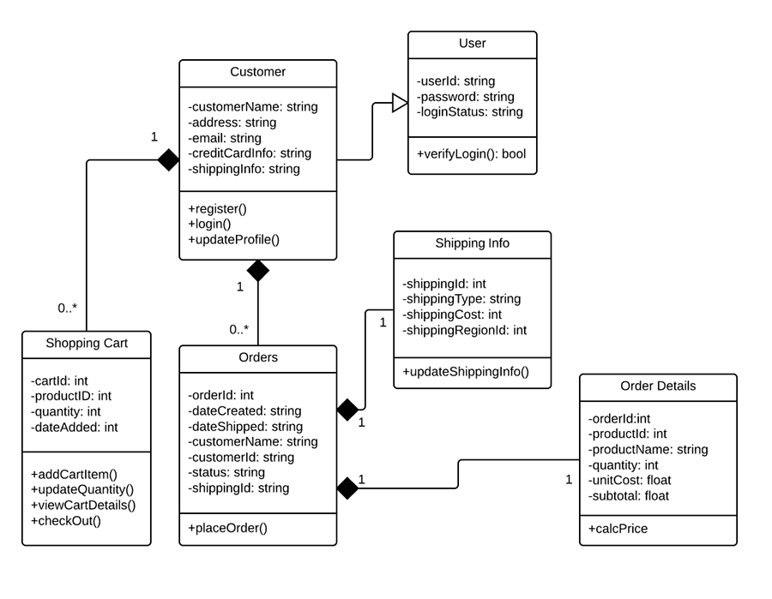

**Figure 4.2:** Class diagram

The class diagram is given above shows a class and the functions used in the project.

### Site Diagram

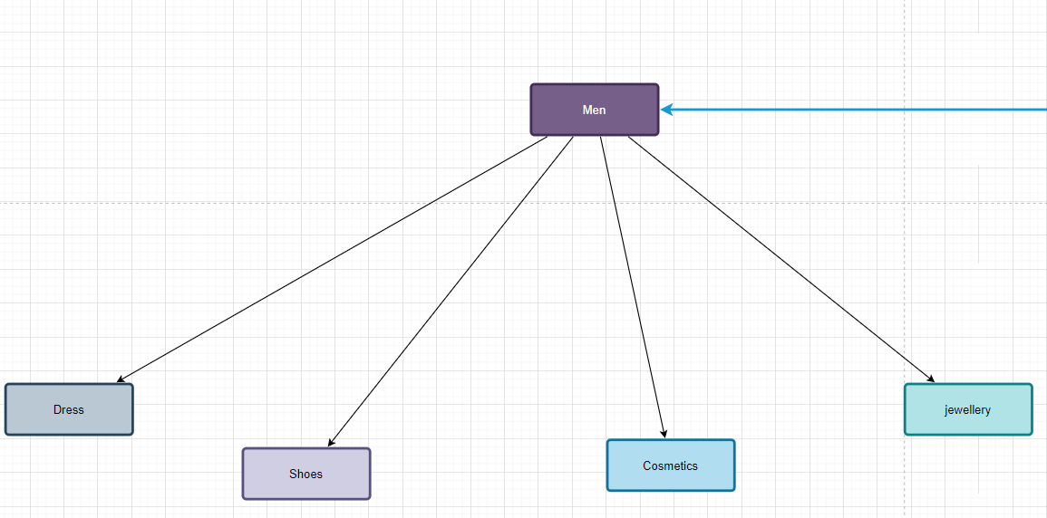

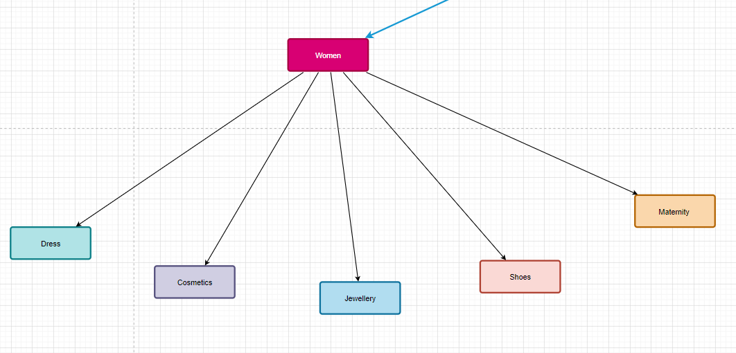

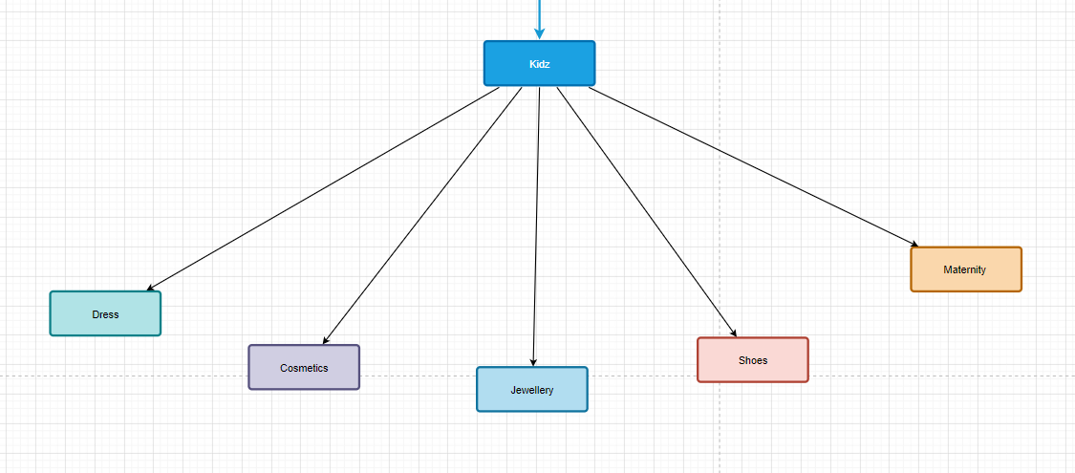

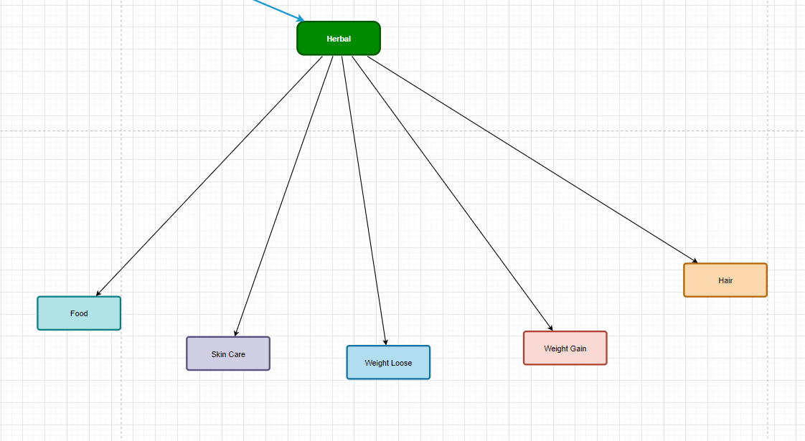

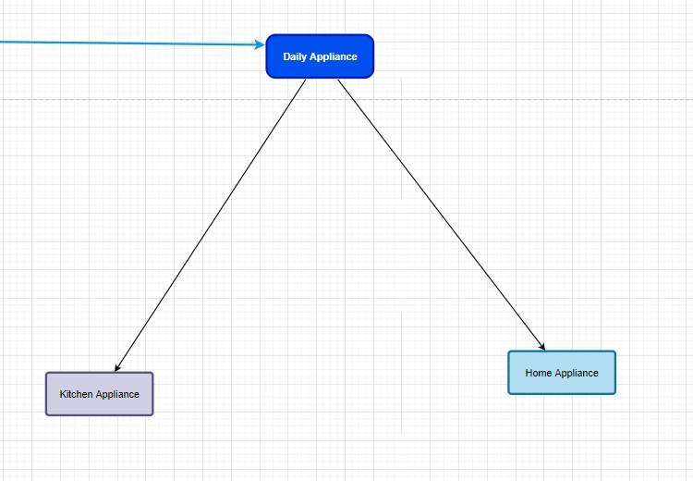

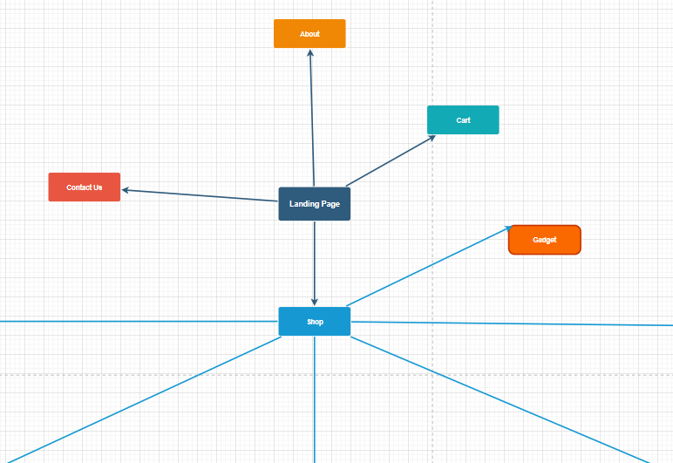

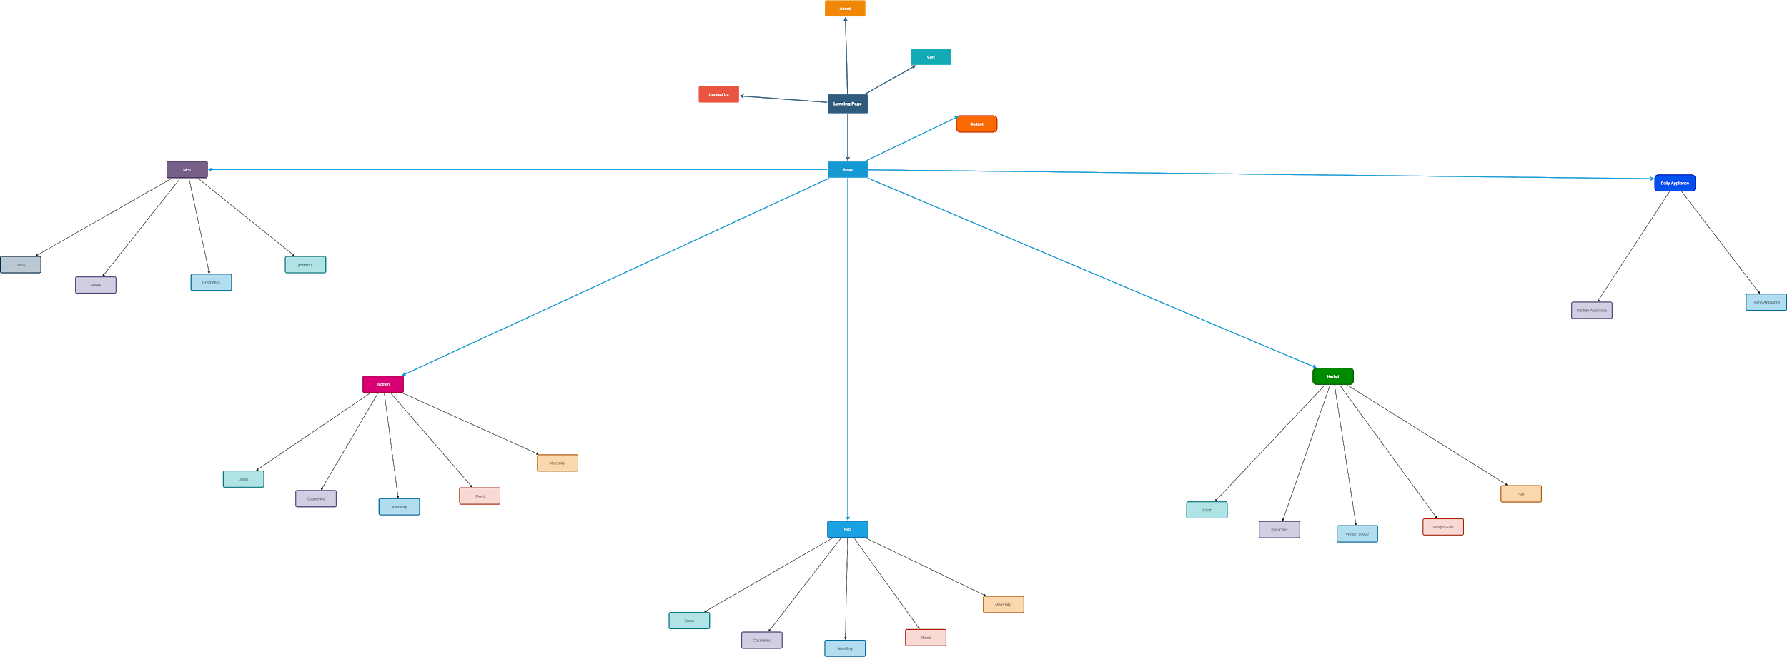

## Project functionalities

1. A user can register as a new member.
2. An existing user can log in.
3. A user can view all products.
4. A user can search for products by category.
5. A user can add any product to the cart.
6. A user can place an order for shipping to his address.

## Implementation

Figure 4.3 shows the home page of this project divided into three-part the header, the body part and the footer part.

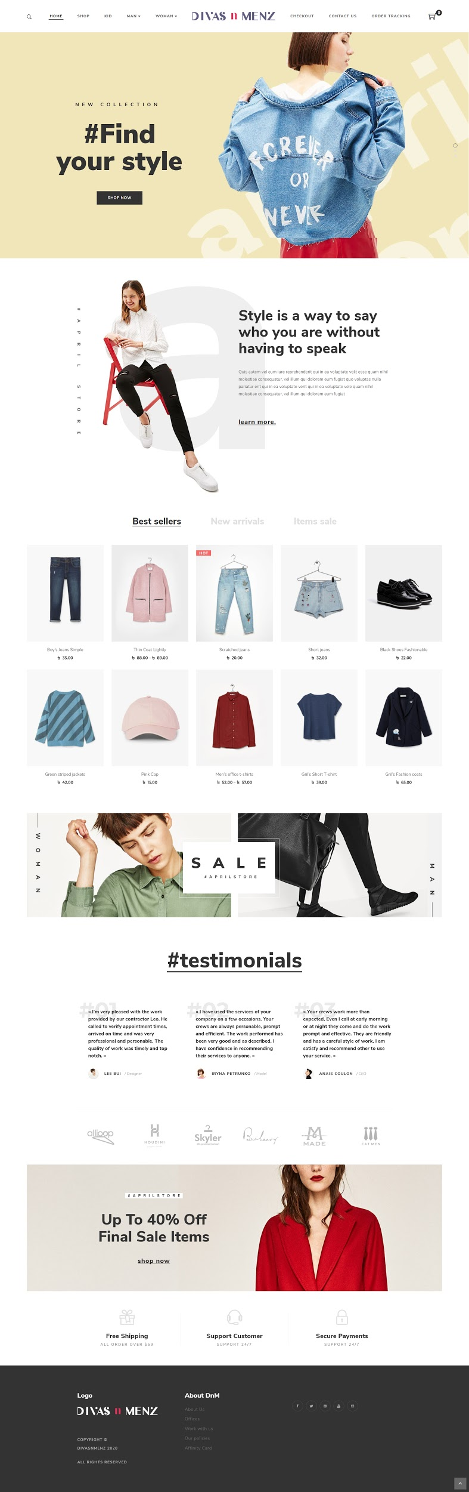

**Figure 4.3:** Home page

On the left side of the header (Figure 4.4) part contains the company’s logo and the right side has a login and registration button which takes the user to the registration and the login page. It also has a menu bar that contains the different product categories. After clicking any of them, it will filter the products and give the user his desired result.



**Figure 4.4:** Header of the project

The body (Figure 4.5) contains the central part of the project which shows the list of all products to the user. A user can easily find their expected product and if a user clicks on any product, he will get a detailed view of that particular product.

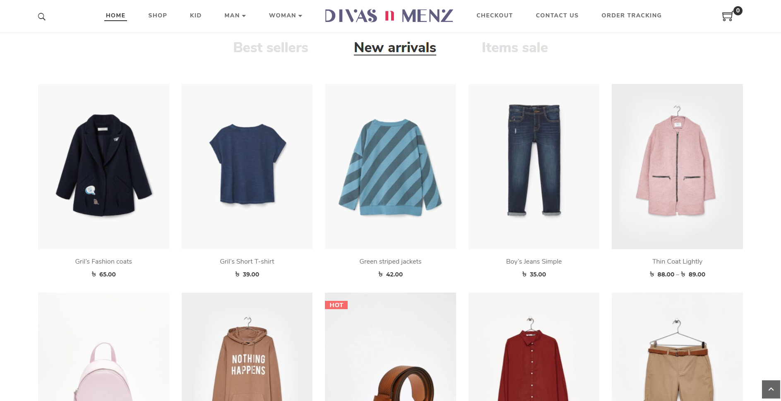

**Figure 4.5:** Body of the project

For importing this product list into our body part, I have used a Woocommerce. Figure 4.6 shows the data in product database.

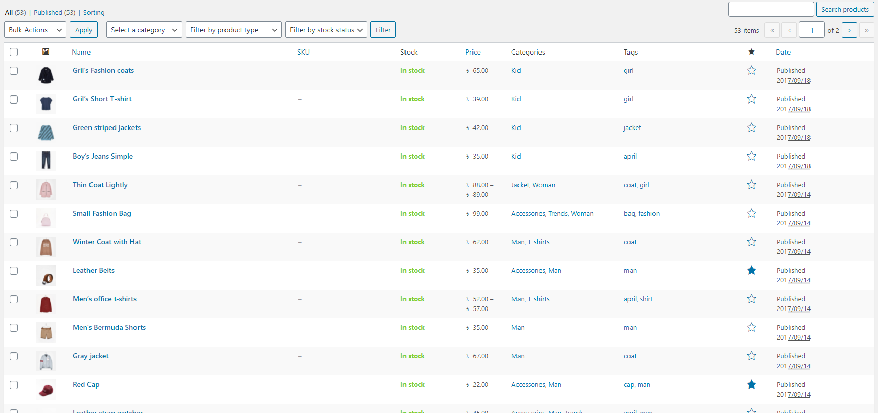

**Figure 4.6:** Product Database

For implementing this data into our body part, I used woocommerce product dashboard. figure 4.7 shows the woocommerce dashboard.

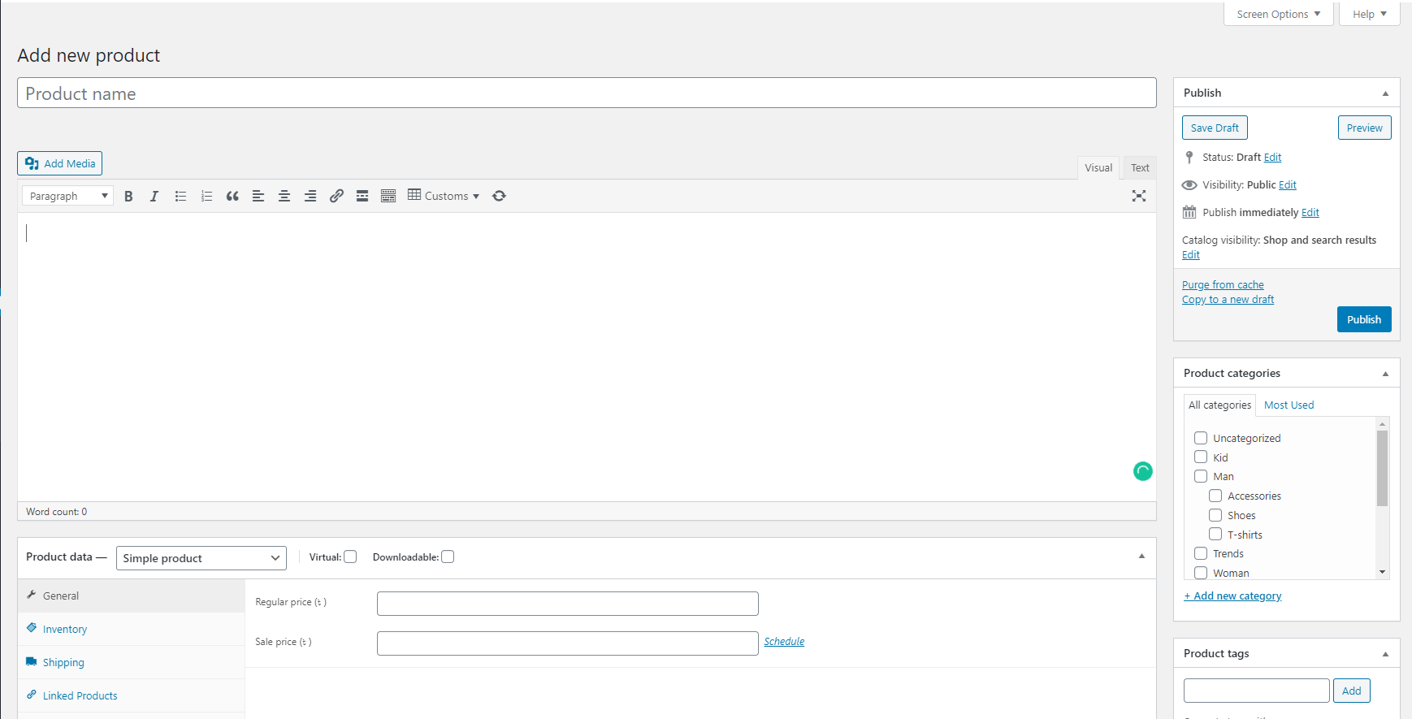

**Figure 4.7:** New Product Add Dashboard

The footer (Figure 4.8) part contains the contact details about the company it is the bottom part of any web page.



**Figure 4.8:** Footer part of the project

This is the complete dashboard of the home page that contains all components of this project and where the WordPress -router-dom module has used for routing data or components one to another.

import WordPress  from 'WordPress ';

import { BrowserRouter, Switch, Route } from 'WordPress -router-dom';

import './App.css';

import Header from "../src/component/Header"

import Body from "../src/component/Body"

import Footer from "../src/component/Footer"

import Subproduct from "../src/component/Subproduct"

import Details from "../src/component/Details"

import Login from "../src/component/Login"

import Register from "../src/component/Register"

import Cart from "../src/component/Cart"

import Checkout from "../src/component/Checkout"

function App() {

  return (

    <div className="App">

     <Header></Header>

     <BrowserRouter>

     <Switch>

     <Route path="/home" component={Body}></Route>

     <Route path="/register" component={Register}></Route>

     <Route path="/checkout:id?" component={Checkout}></Route>

     <Route path="/cart/:id?" component={Cart}></Route>

     <Route path="/login" component={Login}></Route>

     <Route path="/details/:id?" component={Details}></Route>

   <Route path="/category/:id?" component={Subproduct}></Route>

   <Route path="/category/details/:id?" component={Details}></Route>

      </Switch>

     </BrowserRouter>

<Footer></Footer>

    </div>

  );

}

export default App;

**Figure 4.9:** Footer portion of the project

This product details page (Figure 4.10) contains a brief description & other specification of that particular product which is selected by the user from the home page body section and then the user can also add the product on the shopping cart page by clicking the add to cart button.

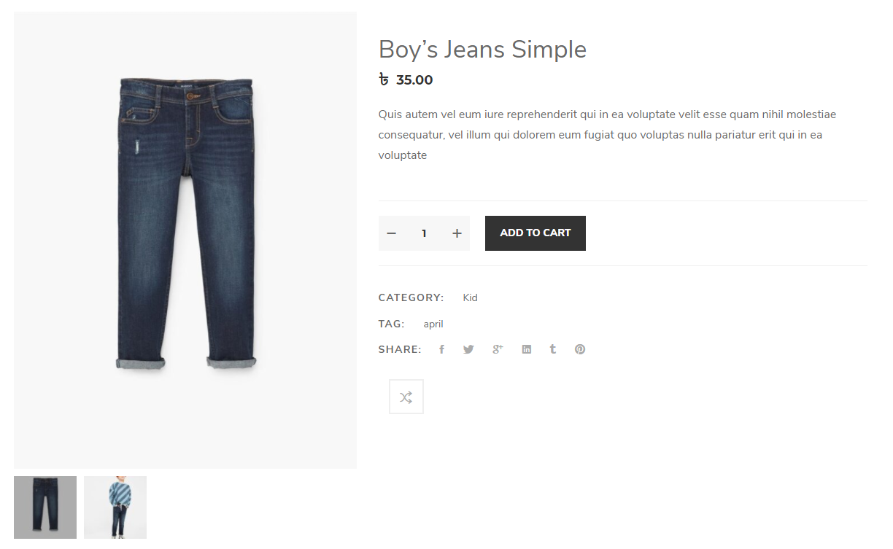

**Figure 4.10:** Product details page.

The cart page (Figure 4.11) shows the information about that product which is selected by the user for placing an order.

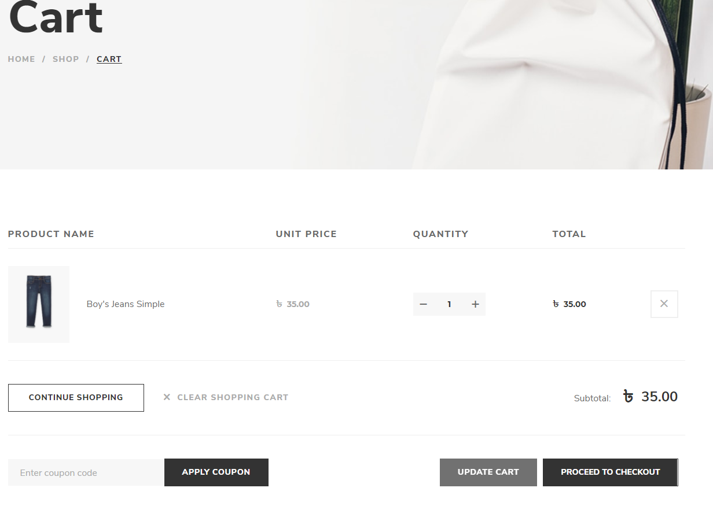

**Figure 4.11:** Cart page of the project.

The checkout page (Figure 4.12) is the final step of any e-commerce application in this stage users have to put their shipping details like his name address contact number and finally hit the place order button and his order will be successfully placed.

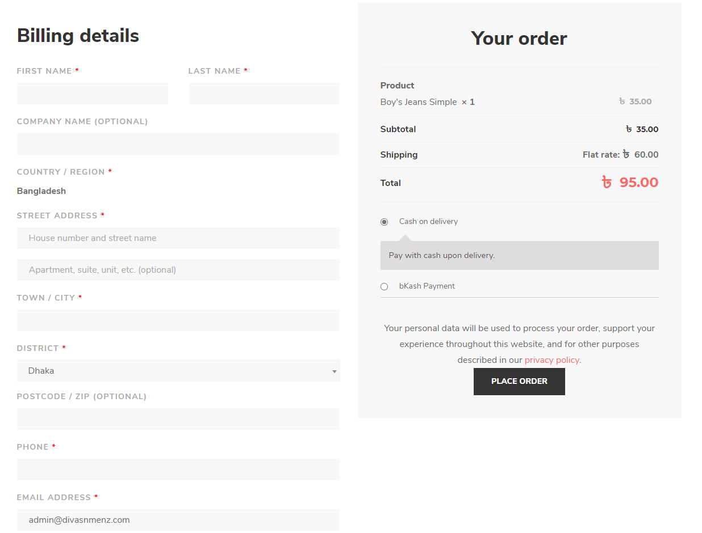

**Figure 4.12:** Cart page of the project.

This is the user registration page (Figure 4.13) of our project. If a user wants to become a member of the site, he just needs to fill out the form and hit the submit button after that he will become a registered member of this site.

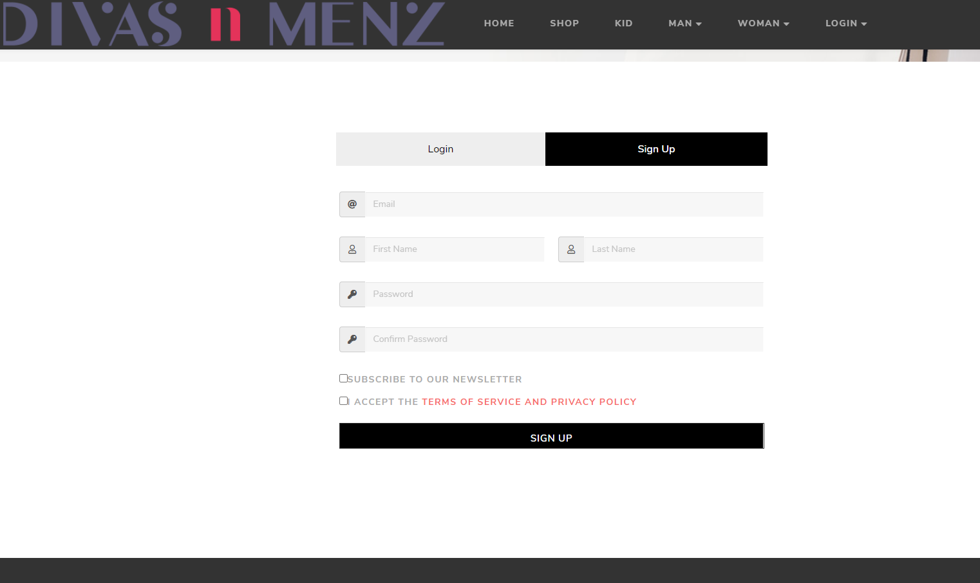

**Figure 4.13:** User registration page of the project.

A registered member can easily log in to this site for completing the checkout process by putting his login details into the user login form (Figure 4.14).

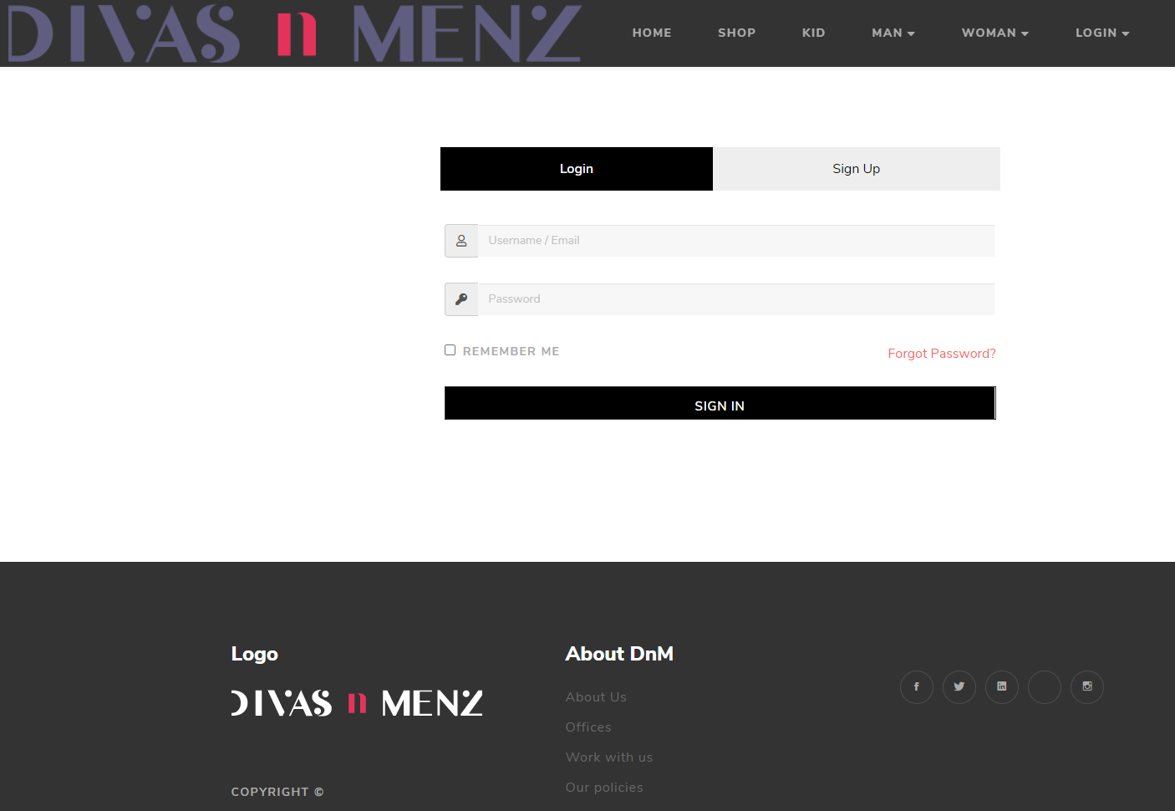

**Figure 4.14:** User login page of the project.

## Database Structure

Figure 4.15 shows the complete database structure of the project.

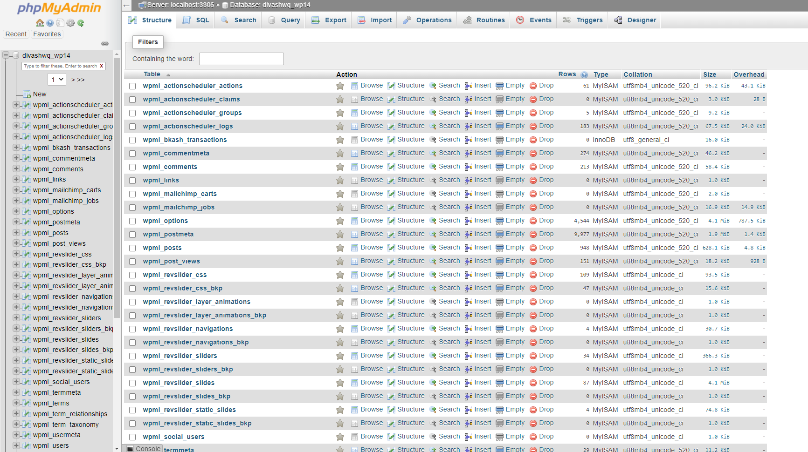

**Figure 4.15:** Database Structure.

Figure 4.16 shows the user table structure of the project.

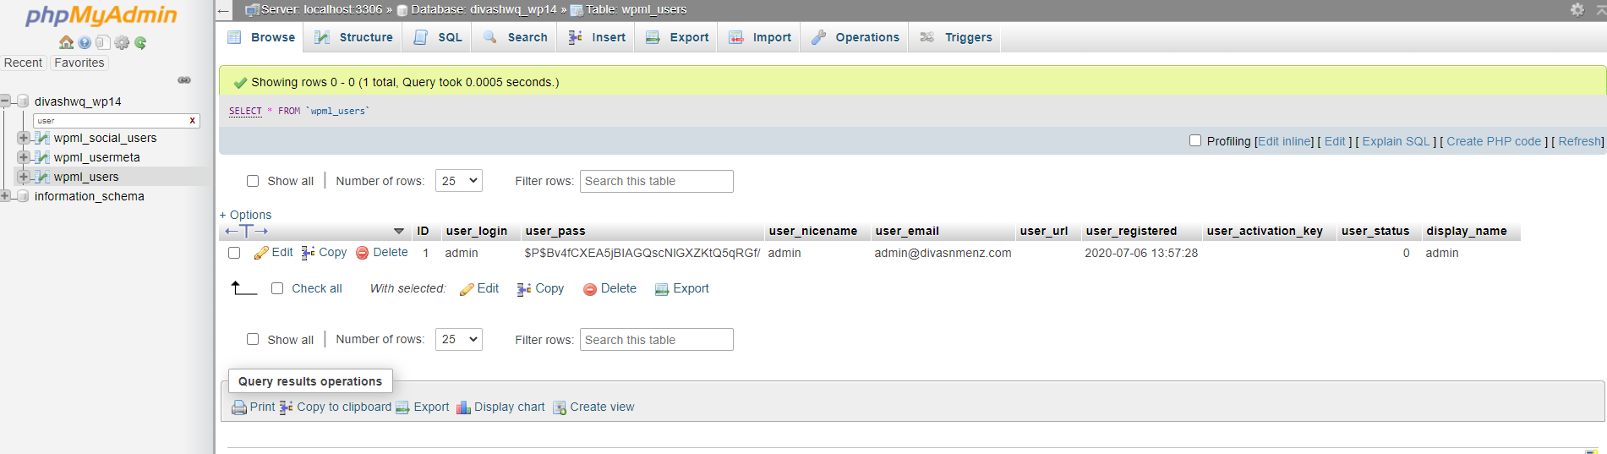

**Figure 4.16:** User Table Database Structure

Figure 4.17 shows the cart table structure of the project.

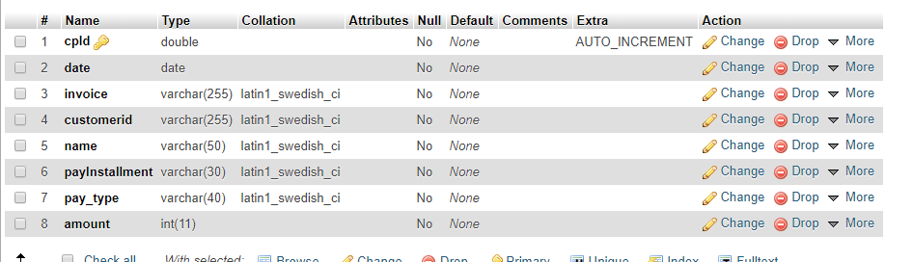

**Figure 4.17:** Cart Table Database Structure

## Project Analysis

I was offered for redeveloping and updating an eCommerce web application which is already developed by REM Eco Savers Ltd. during my intern period. They have established a lot of web applications in the market but for the security and privacy reason they can’t provide me any larger project but they gave me the complete source code of CabHubBD which was developed with WordPress. My job was to convert the basic web application using PHP, Html, Bootstrap, JavaScript, CSS & MySQL.



**Figure 4.18:** Home page of cabhubbd.com

Figure 4.18 is showing the home page of cabhubbd.com which was developed with basic WordPress, for this reason, the website was not completely responsive and it takes a lot of time for loading but during my development process, I have implemented there bootstrap CSS framework that gives the home page a significant look and page become entirely responsive and user friendly and for implementing SCSS and JS the website becomes faster than previous for loading. Figure 4.3 shows the current home page of the project.

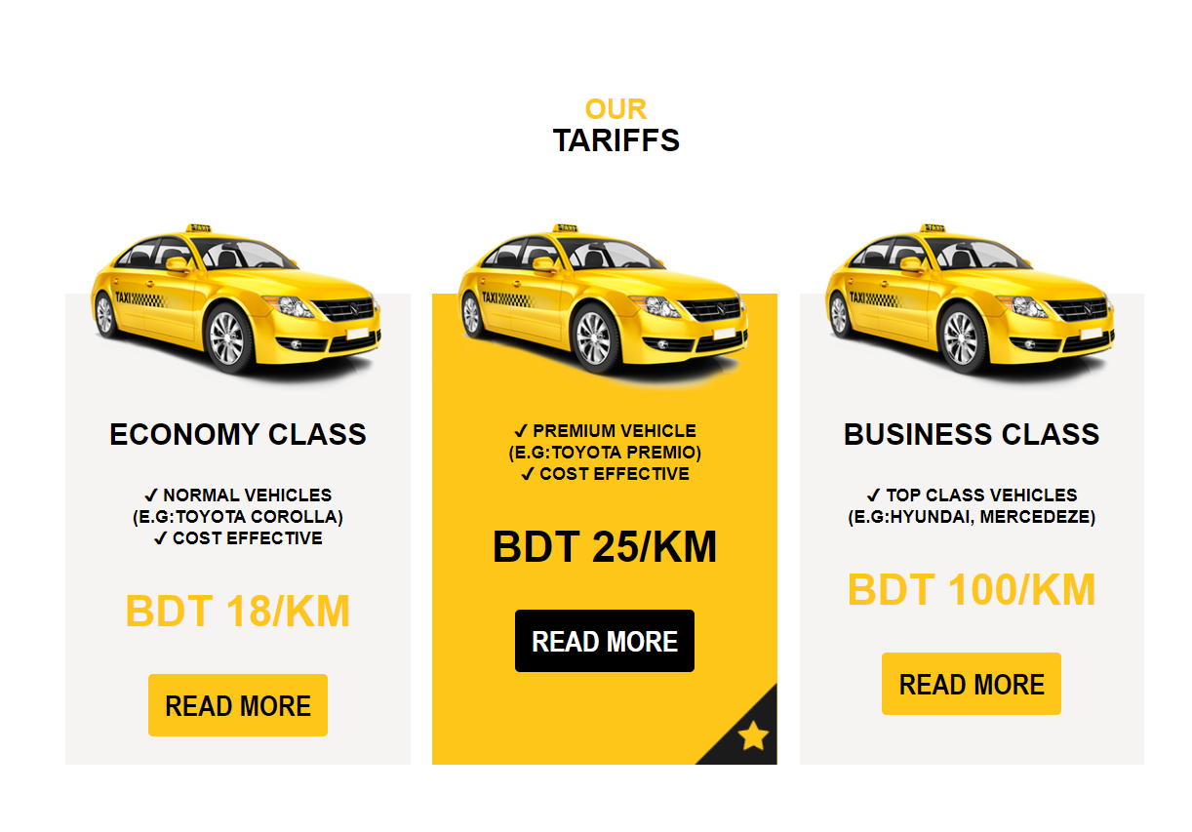

**Figure 4.19:** Service details page of cabhubbd.com

Infigure 4.19 we can see the product details page of cabhubbd.com I also design a newer version of the service details page with bootstrap figure 4.9 shows that and there is no add to cart functionality button on the CabHub BD service details page but I have added a hire cab button which will assign the current can service information into the site In-Service page.

There was no Live Tracking, checkout page, user logging, and registration page into Cab Hub BD previous project but I am working on the live tracking page (Figure 4.11), a checkout page (Figure 4.12), a logging page (Figure 4.14), and a registration page (Figure 4.13) and their functionality into the project.

CONCLUSION

## Conclusion

Working with REM Eco Savers Ltd. as an intern has helped me to understand what is my area of ​​interest. I have gained an immense amount of technical knowledge from this work experience and I plan to continue it for my future career. I believe that my commitment as a web application developer won't solely enhance my career path however additionally, I have to learn new technologies to improve my ability to create changes on my career path.

To extend, as an intern, I have learned WordPress JS for web application development, and to code in a way that my code can be easily changeable, reusable, and easy to fix bugs and profitable and a new programmer can use it after. I used to WordPress JS for my internship project development and while working with WordPress JS, I found it easily learnable, usable, and there is a bright scope for me to choose to WordPress development as a future path.

Also, I set myself some achievement list before the beginning of my internship for my improvement and I am pleased to inform you that my achievement list was achieved precisely. On the other hand, I have learned to acclimate to work in a development team and also in a professional environment. As a web developer, I gain so much confidence dramatically due to my internship. I am ready to work in a professional organization and eager to contribute to growth and profit with all the skills I have acquired.

## Scope of Further Development

Web-based application development is a crucial topic for an e-commerce site. People can browse, choose the products, and order from the company, and the company will be delivered the product within a few days. We have a plan to change and bring a few changes to this website. Besides, we have another plan to add a few functionalities to this website which are given below:

1. Add the chatting system.
2. Have a launch android app.
3. Add SSL commerce in the payment section
4. Enlarge the live tracking of shipping

###### 

Reference

[1] Visual Studio Code - Code Editing. Redefined, "Docs, Getting Started”. Available: <https://code.visualstudio.com/>. [Accessed: 2-July-2020].

[2] Scrum Alliance, "Scrum Role Demystified”. Available: <https://www.scrumalliance.org/agile-resources/scrum-roles-demystified>. [Accessed: 2-July-2020].

[3] Software Testing Materials, "Software Testing Definition, Types”. Available: <https://www.softwaretestingmaterial.com/software-testing/>. [Accessed: 2-July-2020].

[4] “SDLC”, [Online]. Available: [http://istqbexamcertification.com/what-are-the-software-development-life-cycle-sdlc-phases/. [Accessed](http://istqbexamcertification.com/what-are-the-software-development-life-cycle-sdlc-phases/.%20%5bAccessed): 2-July-2020].

[5] J. Duckeet, "Design and Build Websites," in *Design and Build Websites (1'st Edition)*, 2005.[Accessed: 2-July-2020].

[6] w3.org. [Online]. Available: <https://www.w3.org/standards/webdesign/htmlcss>. [Accessed: 2-July-2020].

[7] “Web-based applications”, [Online]. Available: [http://www.magicwebsolutions.co.uk/blog/the-benefits-of-web-based- applications.htm](http://www.magicwebsolutions.co.uk/blog/the-benefits-of-web-based-%20applications.htm). [Accessed: 2-July-2020].

[8] I. Sommervilla, in *Software Engineering,Ninth Edition*, PEARSON.

[Accessed: 2-July-2020].

[9] WordPress Tutorial [Online], Available: [https://www.w3schools.com/WordPress /default.asp](https://www.w3schools.com/REACT/default.asp) [Accessed: 2-July-2020].

[10] JavaScript Tutorial [Online], Available: <https://www.w3schools.com/js/default.asp> [Accessed: 2-July-2020].

[11] CSS Tutorial [Online], Available: <https://www.w3schools.com/css/default.asp> [Accessed: 2-July-2020].

[12] HTML Tutorial [Online], Available: <https://www.w3schools.com/html/default.asp> [Accessed: 2-July-2020].

[13] Primary Components [Online], Available:[https://WordPress training.com/WordPress -router/web/guides/primary-components](https://reacttraining.com/react-router/web/guides/primary-components) [Accessed: 01-May-2020].

[14] What is WordPress? | WordPress 101 Tutorials. <https://ithemes.com/tutorials/what-is-wordpress/>

[15] 19 Interesting Facts About New Hampshire | OhFact!. <https://ohfact.com/interesting-facts-about-new-hampshire/>

[16] 5 Reasons Why We Use WordPress [UPDATED 2017] - Fresh .... <https://www.freshconsulting.com/5-reasons-why-we-use-wordpress/>

[17] How WordPress Actually Works Behind the Scenes (Infographic). <https://www.wpbeginner.com/wp-tutorials/how-wordpress-actually-works-behind-the-scenes-infographic/>